15

Market Analysis
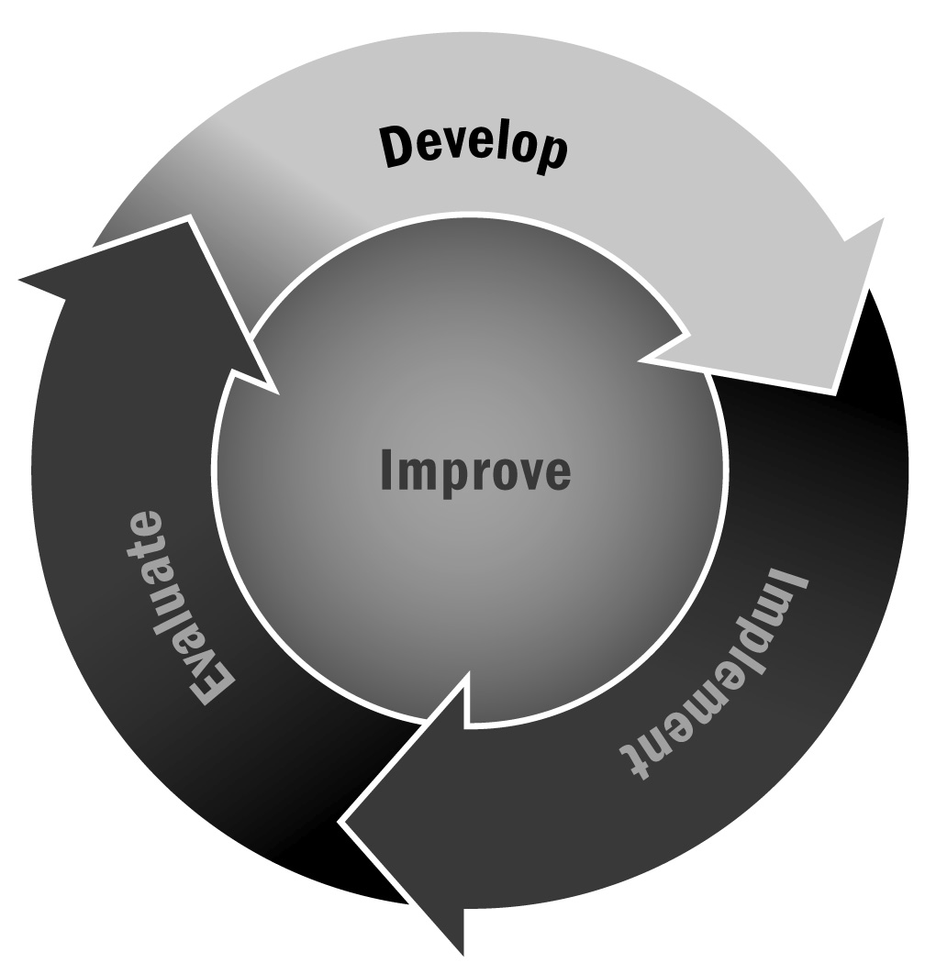
In Chapter 1, you learned that conducting a market analysis is one way to begin to explore resources in your community—funding resources as well as potential partners and supporters. Taking the time to do this will help you in the long run as you work to sustain your program with a diverse funding and partnership base.
Directions: Below we suggest a set of steps for conducting a market analysis. You can follow the steps in order or pick and choose based on your existing knowledge of your community and the types of resources you want to identify. We have included a table at the end of this tool to help you begin collecting information.

Step 1 – Conduct a Community Inventory
The first step is to begin brainstorming all the possible partners in your community that may have an interest in an afterschool and expanded learning program. Think about the following categories of partners:
- School district and individual school staff
- City and county government
- Local funders
- Community-based organizations
- Local colleges and universities
- Research and policy organizations
Keep a comprehensive list of each type of partner and the specific organizations you can think of that are associated with each partner type. Make a note of why you think the potential partner may be interested in your program or what type of partnership you might have with the organization. It is a good idea to include a variety of people (e.g., your staff, advisory board, board of directors, etc.) in the brainstorming process in order to draw up a comprehensive list.
Step 2 – Identify Key Informants and Conduct Interviews
Think about key informants in each of the groups above and set up a time to talk with each one. These can be informal conversations or more formal interviews. Questions you might consider asking include:
- Can you think of ways our program could help your organization achieve its core mission?
- Who is your target population?
- Are there ways we can partner to increase efficiency or reduce costs for both of us?
- What kinds of resources might you (or similar organizations) be able to contribute to the afterschool and expanded learning program?
- How should I think about approaching other [insert type of organization here] to discuss the possibilities of partnering? Are there any you think are particularly worth reaching out to?
Step 3 – Collect and Capture Data
Be sure to capture all of the data you are gathering through your inventory and your interviews. You can start by using the table we have provided with this tool. You may also want to create an Excel spreadsheet or other database to capture information about each potential partner, which you can add to over time as you gather new data. Be sure to note potential contacts, types of resources, and other details about their possible interest in your program and afterschool and expanded learning in general. The more comprehensive your data, the more actionable it will be.

Step 4 – Turn Your Data Into Action Steps
Although a market analysis isn’t actually a plan for action, it is a good idea to take the information you capture through this market analysis activity and turn it into a set of next steps. Using the table that follows, identify specific staff members to follow up on each activity. If possible, include a timeline for each next step. These don’t have to be comprehensive and detailed, but they should include actions you can take to move your market analysis into its next logical phase.

Capturing Market Analysis Data
Name of Resource | Type of Support/Resource | Notes/Next Steps
Funders
Example – Community Foundation | Provide small grants for professional development for program staff members | Program director will follow up with program officer to establish meeting to discuss (by Dec. 4)
Partners
Example – The local Y | May be willing to bring Y on the Move bus to program for additional sports enrichment | Education director will contact Y on the Move director to discuss fall programming (by Sept. 15)
Now What? In the end, you will have a comprehensive set of potential partners and resources, and you may make some friends and meet collaborators on the way. At the very least, you have raised awareness about afterschool and expanded learning and your program’s vision.

